9/17/2025

**API TESTING**

**REPORT**

* **INTRODUCTION:**

This report includes the process and outcomes of API testing performed using the Postman tool. The purpose of the testing was to validate the functionality of various HTTP methods (GET, POST, PUT, PATCH, DELETE) in an API.

* **OBJECTIVES:**
* To test the functionality of different HTTP request methods.
* To verify the expected responses and status codes for each request type.
* To ensure correct creation, retrieval, updating, and deletion of user data.
* **TOOL USED:**

**Postman**: A widely used API testing tool that allows users to send HTTP requests to RESTful APIs and view responses in a user-friendly interface

* **API TESTING PROCESS:**
* **GET Request**

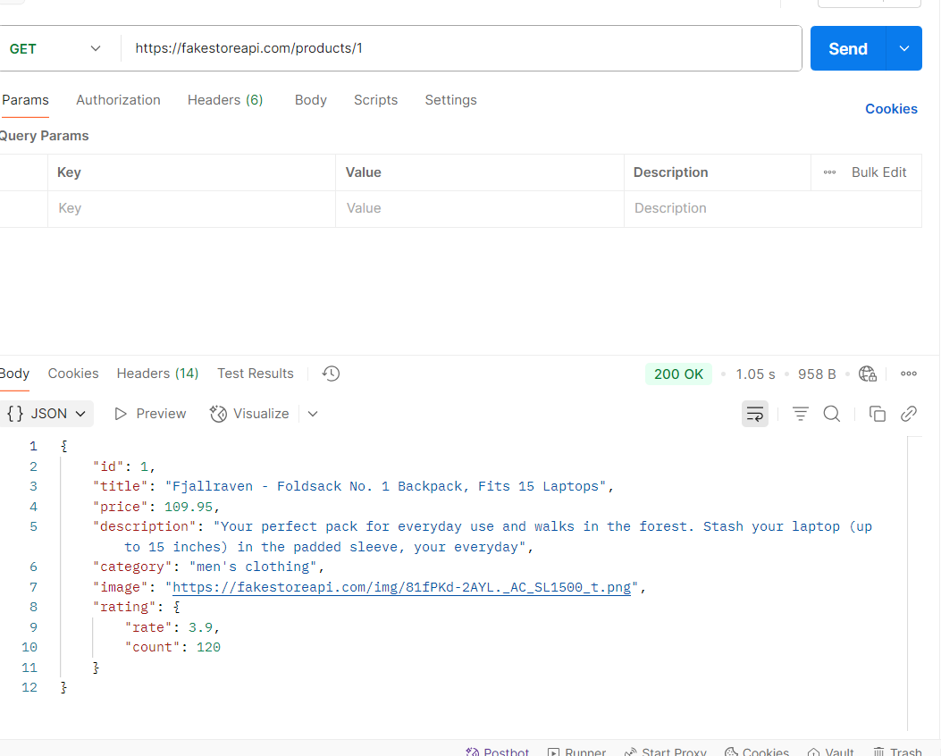

* **POST Request**

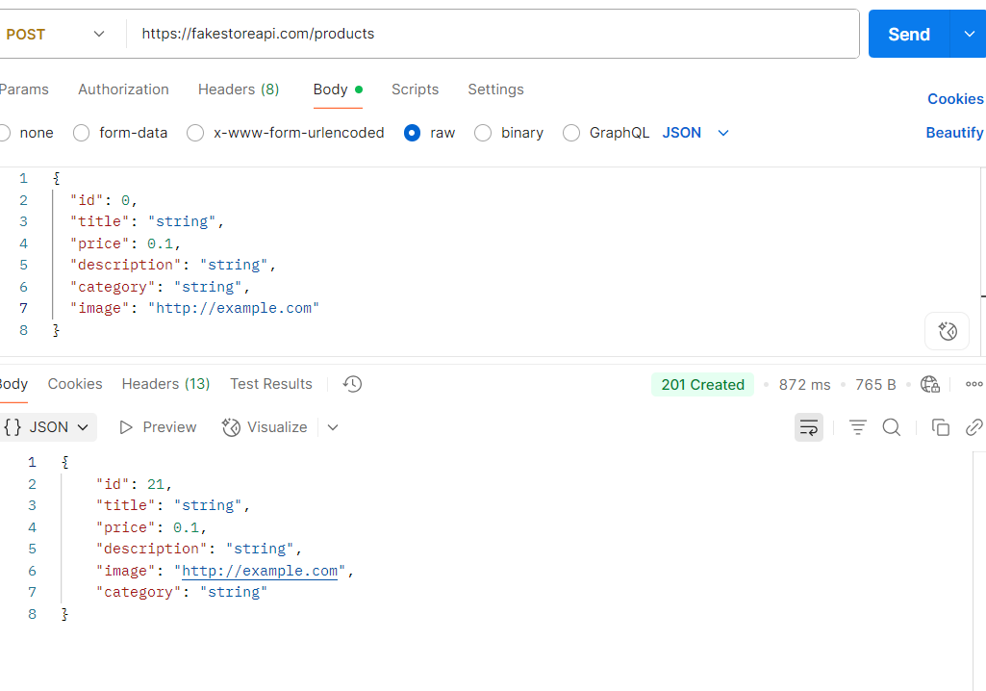

* **PUT Request**

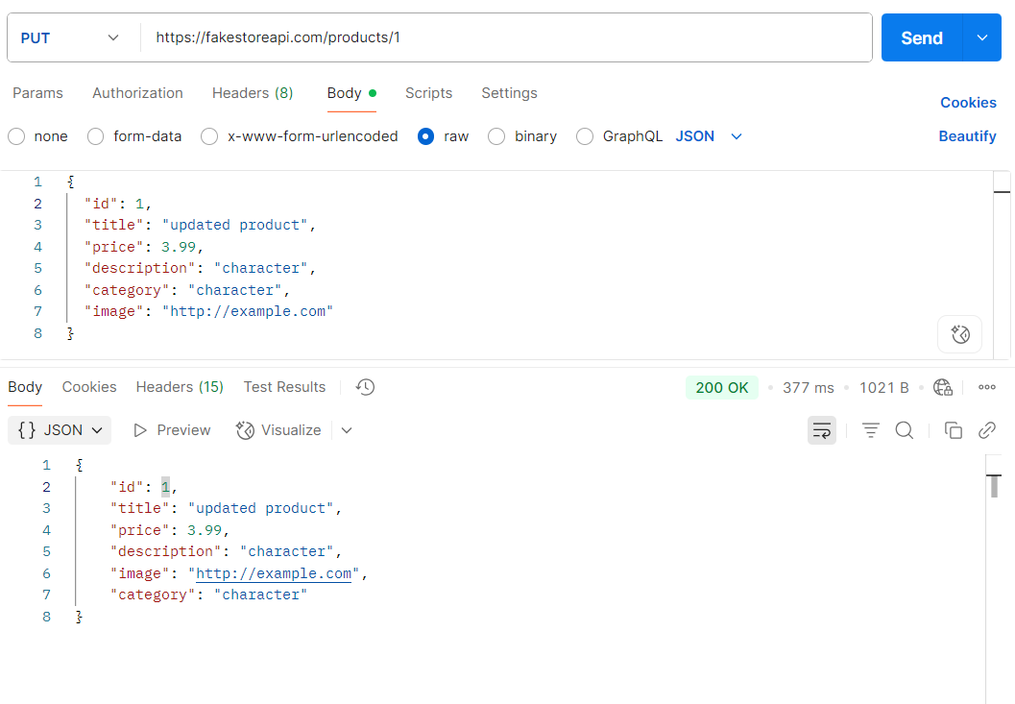

* 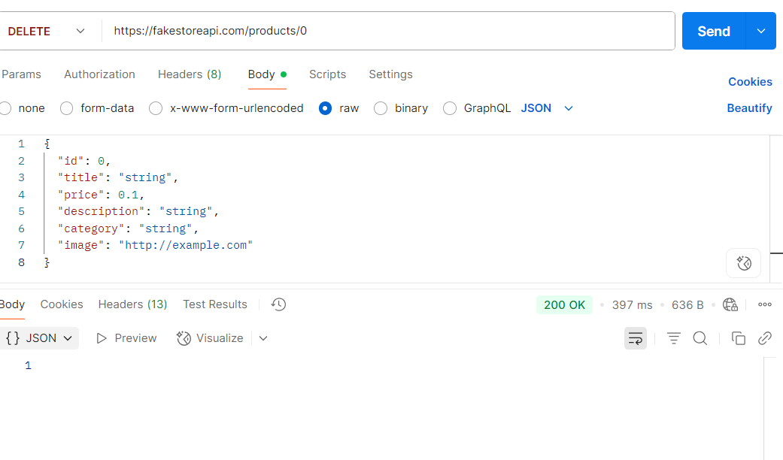**DELETE Request**
* **CONCLUSION**

The API testing conducted through Postman confirmed that the endpoints are functioning as expected. Each HTTP method produced the correct status code and response, demonstrating that the API can effectively handle user data operations, including retrieval, creation, updating, and deletion.